St Bart’s – check - Reflection Areas in Classrooms 20-21
All reflection areas must contain the following:
- A cross
- A candle (tea light).
- A class prayer.
- The Lord’s Prayer.
- A way in which children can write their prayers if wanted (see plan).
- An interactive activity linked to a big question (see plan).
- A reference to the Rainbow value for the half term.
- A children's bible.
- A reflection Book where responses are collected from class prayer, worships and also where the responses from the big questions are kept when taken down. Prayers can be kept and shared if you have permission from the child.
Term | Rainbow Value | Bible story underpinning value. | Big Question Interactive activity. | Prayer Activity
Autumn 1 | Courage  Love | David and Goliath 1:Samuel 17:1-54  1 Corinthians 13:4-8 | If you could ask God one question, what would it be?  Children to use the phone in the reflection areas to ‘phone God’ and ask him a question. Older children could write their question on a telephone template and display on reflection area. Adult to scribe for younger children. | Sand prayer.  Place a small tray of sand in the reflection area. Children to draw a picture of someone they love in the sand and say a prayer for them. Children to write their prayer on hearts if they want to and place in prayer box.  “Use your finger in the sand to quietly draw someone you love, say their name to God. You could even say a prayer if you wish”.
Autumn 2 | Hope  Aspiration | Hope: The Resurrection  Matthew 28:1-7  Aspiration: The Road to Damascus  Acts 9:1-25 | What would you like to be remembered for?  Children write responses on a poppy template and display in reflection area. (Link made to remembrance day/ RBL affiliation). | A pine tree prayer.  Have a little tree in your reflection area. Children to write a little prayer on a decoration and add to the tree. Could make further reference to Christmas prayers when we get closer to December.
Spring 1 | Compassion | The Good Samaritan  Luke 10:29-37 | Who would you give your last sweet to and why?  Have a sealed jar of sweets in the classroom with some money for the children to explore. Record children’s responses on sweet template and display in reflection area. | Write a prayer for someone you know who is unwell or needs someone to show them compassion.  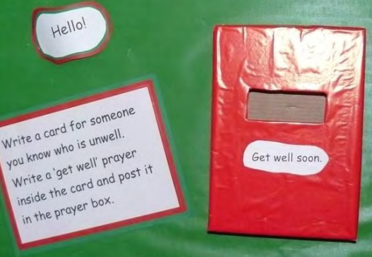
Spring 2 | Forgiveness | The Prodigal Son  Luke 15:11-32 | Should all bad people be punished?  Have a pair of child’s handcuffs in the reflection area and police items used to promote discussion about big question. Record children’s responses and add to the jail template. | Lego Prayers  Say a prayer for someone who shares your home as you add another brick to the Lego house.  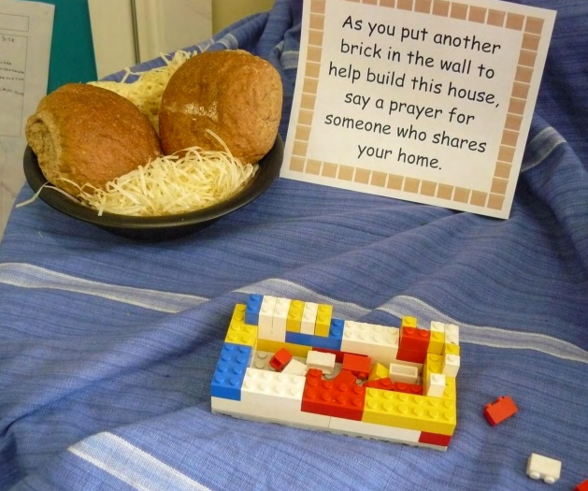
Summer 1 | Trust | The Annunciation and Birth of Jesus  Luke 1:26-33, 2:1-7 | If you were God for the day what would you do?  Children to add their response to the job list on the clipboard. Include hard hat and high vis jacket in each area. | Confetti Prayers.  Choose a lolly pop stick from the jar and write a prayer for that person. When a child has written a prayer they can choose 10 bits of confetti to add to the jar. At the end of the half term each child will get a handful of confetti to throw in the air and say a prayer.
Summer 2 | Respect | The Ten Commandments  Exodus 20 | If you could do one thing to reverse Climate change what would it be?  Children to write their responses/ responses on a pot it note and put it in a plastic bottle. | Prayer rocks  Choose a prayer rock and write a prayer for someone who needs it.  