Pupil Chaplaincy
Introduction
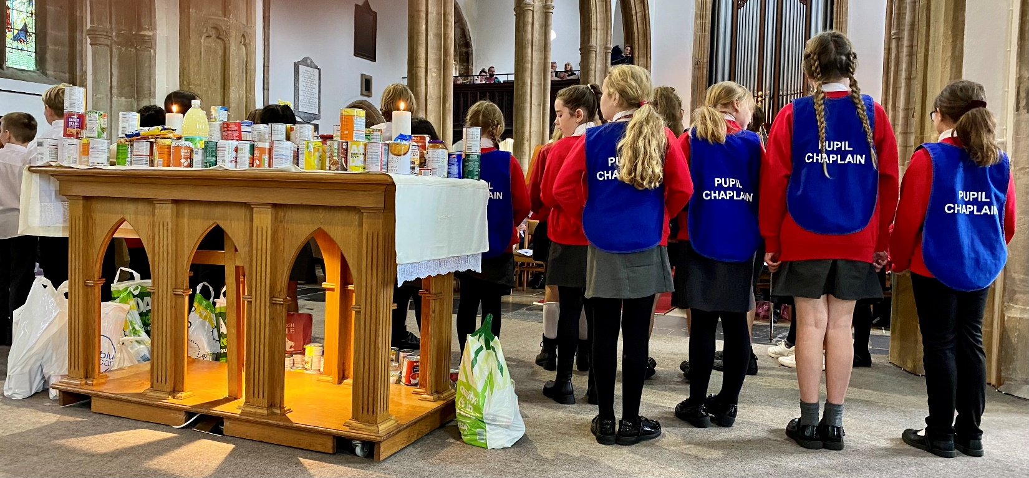
Pupil Chaplaincy is one of the fastest areas of chaplaincy growth in the Diocese Bath and Wells, and beyond. We have been inspired by the Roman Catholic Diocese of Clifton and are grateful for their support. Pupil Chaplaincy teams are supported by School Chaplains and the school and the church as they live out their ministry. The majority of the content in this toolkit is drawn from the Primary sector, but there are also growing numbers of Pupil Chaplains in Secondary Schools. We have used the terminology of ‘Pupil Chaplaincy’ throughout, but it could easily be changed to ‘Student Chaplaincy’. We hope that this toolkit will give you some helpful information about Pupil Chaplaincy and how to set it up in your school. If you have any questions, please contact mike.haslam@bathwells.anglican.org.

Pupil Chaplaincy Role Description: Draft
The role description will vary from primary to secondary and from school to school. This draft role description is a possible starting point.

Working with the School Chaplain, local churches and school staff, pupil chaplains will:
- Actively live out the school values.
- Be good listeners, to support fellow pupils who ask for help, and to encourage them to speak to an adult who can more fully support their emotional and spiritual health and well-being.
- Help to plan and lead collective worship and festival services in church.
- Co-ordinate and organise charity fundraising events.
- Represent the school and offer practical support for school and community projects involving elderly people and those in need.

In some contexts, the roles of the pupil chaplains have been sub-divided.
Worship Chaplains
Working with clergy, chaplains and school staff to:
- lead occasional parts of the worship in assemblies and school services.
- tell the stories of Christianity and Bible stories supporting the school values in a range of settings in the school and community; for instance, using music and drama, making a short film, writing a prayer, creating a space that explores a story and value, puppets and other ideas for creative storytelling.
- explore stories of hope from the Christian tradition by listening to readers or reading the stories to younger children.
- support reflective spaces and opportunities for creative prayer throughout the life of the school.

Community Chaplains
- Represent the school and offer practical support for school and community projects involving elderly people and those with dementia, or food banks or environmental projects. Lead fundraising events and get involved in the projects.
- Organise a project that will help children who feel lonely, for instance a buddy or listening bench.
- Be a safe person in school that is there to listen and help children wanting to talk, for instance as a mentor or playground buddy.

Qualities looked for in pupil chaplains
Pupil chaplains will be:
- role models of the vision and values of the school and able to start again after making mistakes.
- committed to exploring Christian beliefs, stories and values.
- keen to help others by listening and offering support.
- willing to help plan and lead Collective Worship in school and church.

Pupil Chaplaincy Recruitment, Training and Development:
- Information will be circulated about the opportunities to pupils, staff, parents/carers and church members. This can include the role description and qualities [above]. The story of Esther, or another bible story, can be told to pupils to model the balance of values, worship, pastoral care needed in the role. Is this the right time for a potential pupil chaplain to step forward, as it was for Esther?
- Pupils will volunteer to apply to become a student chaplain and write a letter of application, support can be given with this. A verbal or written reference can be sought from a member of staff.
- Permission from parents/carers to be gained for those pupils appointed, this will include permission for photography.
- Pupil Chaplains to be announced and introduced to the school.
- Basic training to be offered to the Pupil Chaplains. This can include:
  - training in listening and pastoral care.
  - values exercises, which can lead into the writing of their own promises [the draft role description can also be adapted for each school context].
  - planning the Commissioning Service, which will be formed around the promises the Pupil Chaplains have written, and can also include a Bible Reading, music and prayers.
  - an introduction to safeguarding and particularly boundaries and how to refer any concerns.
Mike Haslam is available to support the training.
- Commissioning of the Pupil Chaplains. Mike Haslam is available to support the commissioning.
- Regular meetings, ideally once a week, and at least once a month, to allow the Pupil Chaplains to learn more of the Christian Faith, through prayer, bible study and service, and to plan collective worship and other activities and review their listening and pastoral care ministry. These meetings also offer help to Pupil Chaplains when things have been hard or when mistakes have been made.
- Pupil Chaplains will be asked to help us review the programme at the end of the year and suggest improvements and ideas to make it work better in the school, community and for all those involved.
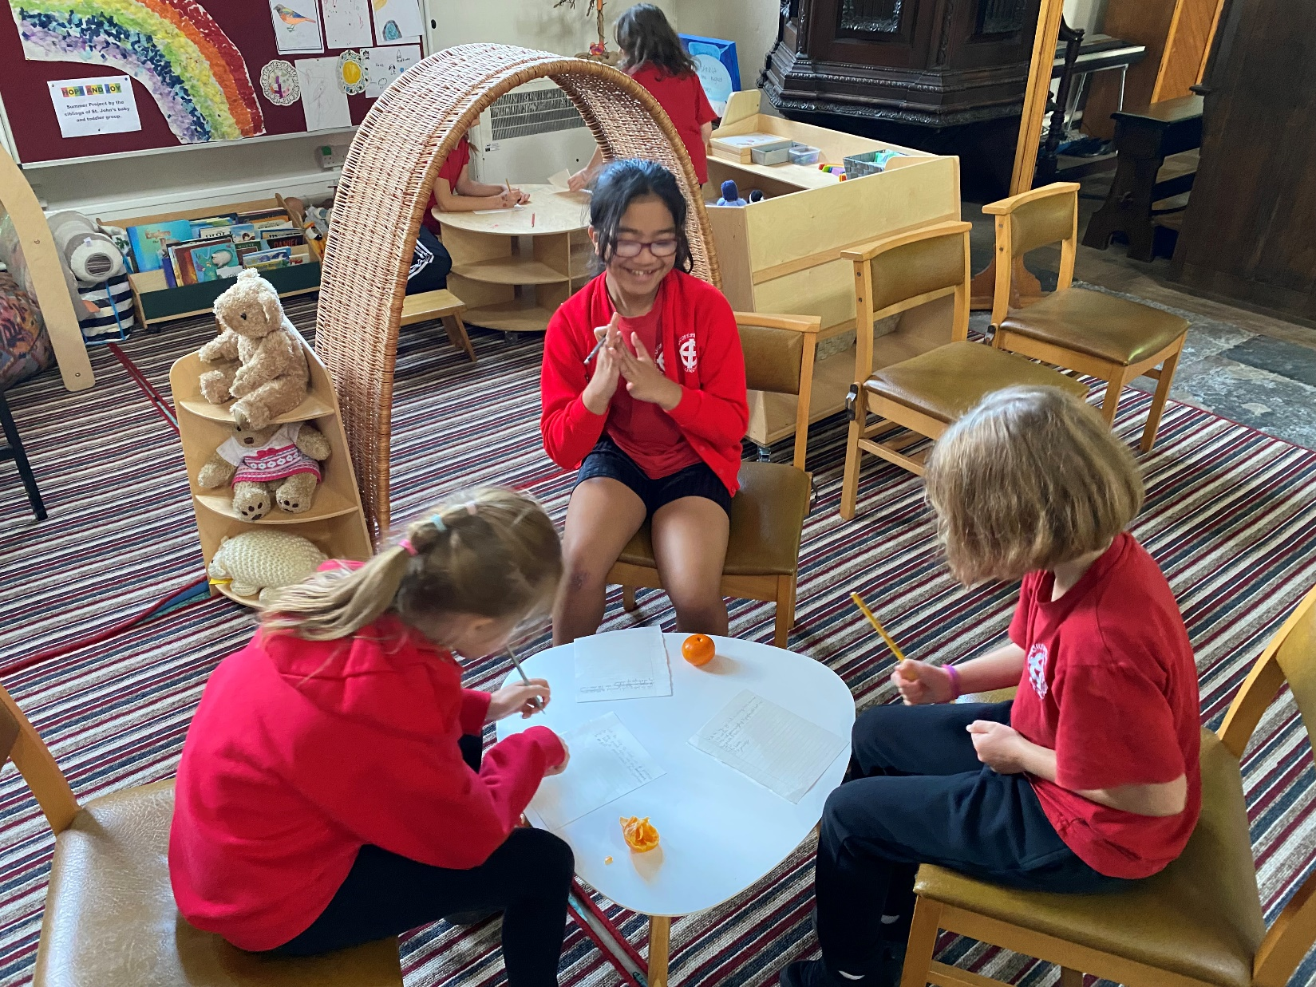

Next Steps
If a conversation about Pupil Chaplaincy would be helpful, please contact Mike Haslam, Chaplaincy Adviser, on mike.haslam@bathwells.anglican.org or 07530 677493.
The School Chaplaincy Toolkit may also be helpful in developing chaplaincy in your school.

